UL Data Listing & Its Manufacturer Capabilities Highlighted Below
As per the related UL rules and regulation, all the capability of each manufacturer cannot be claimed by herself, but has to be manifested and homologated with UL. Otherwise you are not allowed to print your UL number, model and logo on the boards.
In 2024, the top EMS manufacturers in the world 1. Foxconn, Inventec, AsusTek,Quanta Computer,Taiwan; 2. Flextronics, Venture, GES, Singapore; 3 Jabil, Sanmina-SCI, Benchmark, Plexus, Solectron, USA; 4. Celestica, SMTC, Creation Technologies, Canada; 5 Elcoteq, Scanfil EMS, PKC Group, Finland; 6. Siix, Di-Nikko Engineering,Nippon Manufacturing Service, Japan; 7 NamTai Electronics, WKK Technology Ltd., Hong Kong; 8. Zollner Elektronik, Vogt, German; 9. éolane, ALL CIRCUITS, LACROIX Electronics, France; 10. Enics, Switzerland, etc declared that they will not purchase PCBs not conformed to UL new rules for assembly solder 6 Cycles under min. 260C at https://iq.ulprospector.com/en/profile?e=203598
The HD-10 UL listing for PCBs, with a minimum track width of only 0.02mm (0.78 mil), which is less than half the diameter of a human hair, is currently the number one in the world, as verified by UL
The HD-ML16, HD-MC16, and HD-D16 UL listings for single-sided, double-sided, and multilayer PCBs are currently the number one in the world for applications with a 150°C operating temperature, as tested and certified by UL Labs.
The HD-M29 and HD-M30 UL listings for heavy copper PCBs, with inner layer copper thickness of 212 µm, position us as the third top PCB manufacturer in the world.

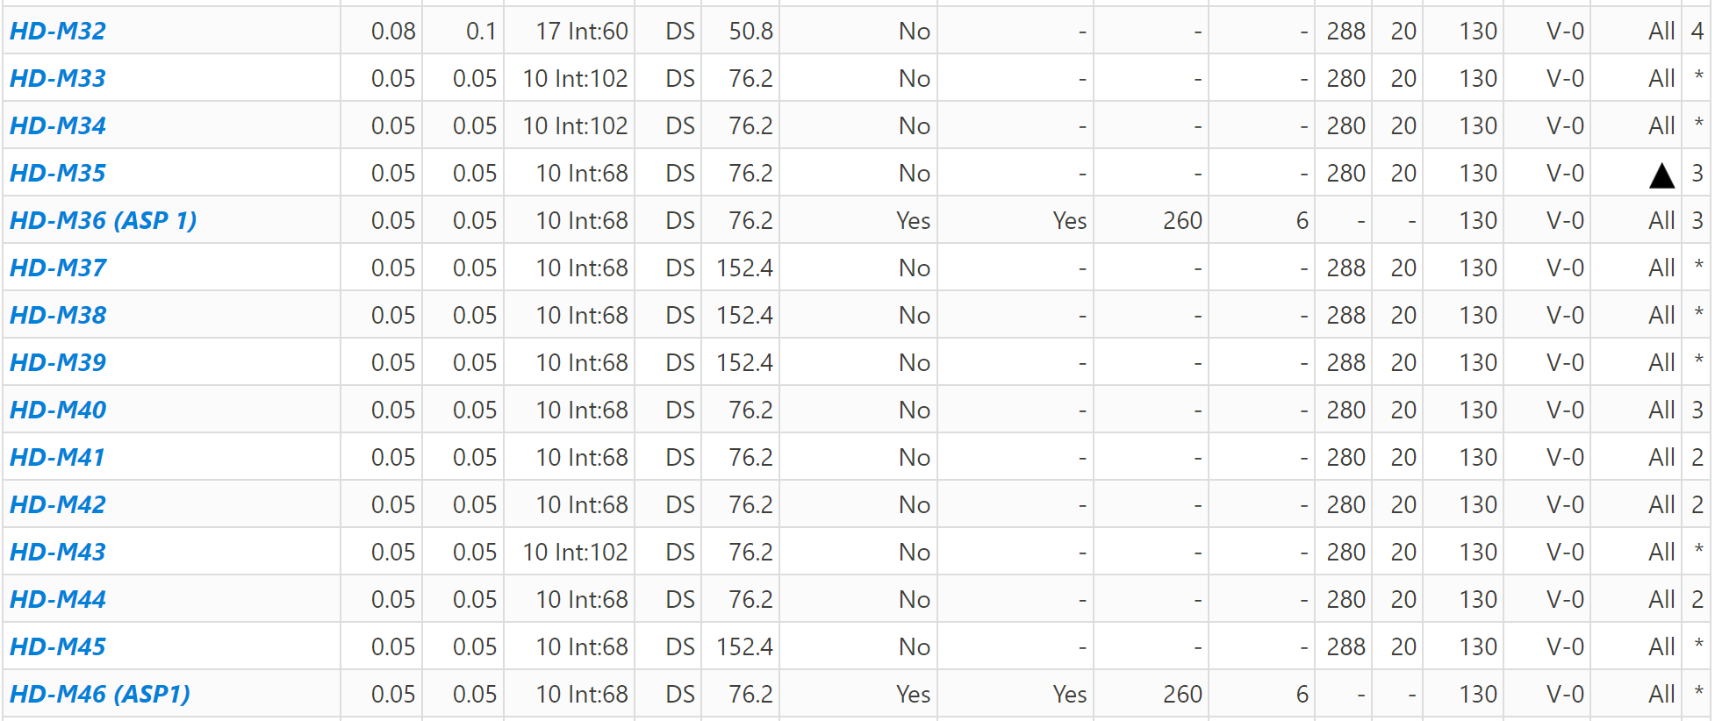
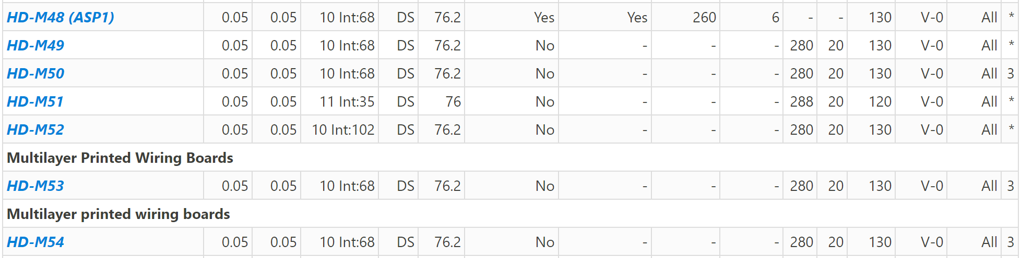
The 22 UL listings for HDI (High Density Interconnection) and ICS (IC Substrate) PCBs, with a minimum line and space of 0.05mm (2 mils), place us among the top six PCB manufacturers globally for 1-n-1, 2-n-2, 3-n-3, 4-n-4 PCBs or any layer configuration.

Additionally, the HD-M36, HD-M46, and HD-M48 UL listings for HDI and ICS PCBs have been upgraded to meet the highest standards, according to UL's new guidelines for assembly solder temperature of 260°C for 6 cycles, ensuring a product service life of over 10 years. In contrast, 99% of PCB manufacturers worldwide, including those in China, have not made this upgrade or have only achieved upgrades for 1-3 cycles, with product lifespans of 1-5 year

